|  |
| --- |
| This unit introduces basic principles of good paragraph construction. As you write and revise your essay, you should check if you follow these principles. |

**Reflection**

# By the time they reach university, most students have been taught a great deal about how to plan and write paragraphs, but they are often taught different things.

**Task 1: Discussion**

1. In pairs or small group, discuss what you have been taught about paragraph writing prior to coming to CityU.

* What similarities can you discover?
* What differences have you experienced in this area?

2. After your discussion, compare ideas with another pair or group.

**Task 2: Analysis**

1. In the table below, there are nine sentences. If the sentences are correctly re-ordered, they make up a coherent paragraph. Write numbers in Column 2 to indicate the most logical sentence order. Two have been done for you as examples.

|  |  |
| --- | --- |
| **Sentences** | **Order** |
| Finally, a well-constructed paragraph shows clear links from one sentence to the next. This can be achieved, in part, by the use of pronouns (for example, "this", "she" or "they") and linking words and phrases (such as "Furthermore" or "One consequence is…"). |  |
| With practice, it becomes progressively easier to construct paragraphs which adhere to these three principles. |  |
| Another important consideration is that everything in the paragraph should relate back to this controlling idea. |  |
| There are several things to think about when writing a paragraph in an English-language essay. | **1** |
| By placing it in this initial position, a writer can help to focus the reader's attention on the main or "controlling" idea. |  |
| Such use of pronouns and connecting language helps to provide what is known as *cohesion* (literally "sticking together"). |  |
| This is a sentence that informs the reader of the main idea which is being developed. It is usually, but not always, the first sentence of the paragraph. |  |
| One is that there should be a single, clear focus to the paragraph, normally expressed in a *topic sentence*. |  |
| Without this kind of connection within a paragraph, it becomes little more than a random string of sentences with no internal logic. | **6** |

When you have finished, compare answers with a classmate. How did you decide on the order of the sentences?

2. Here is the re-constructed paragraph. Highlight any pronouns which refer back to a previous sentence and any linking words. Two examples have been highlighted for you in the paragraph.

|  |
| --- |
| There are several things to think about when writing a paragraph in an English-language essay. One is that there should be a single, clear focus to the paragraph, normally expressed in a *topic sentence*. This is a sentence that informs the reader of the main idea which is being developed. It is usually, but not always, the first sentence of the paragraph. By placing it in this initial position, a writer can help to focus the reader's attention on the main or "controlling" idea. Another important consideration is that everything in the paragraph should relate back to this controlling idea. Without this kind of connection within a paragraph, it becomes little more than a random string of sentences with no internal logic. Finally, a well-constructed paragraph shows clear links from one sentence to the next. This can be achieved, in part, by the use of pronouns (for example, "this", "she" or "they") and linking words and phrases (such as "furthermore" or "One consequence is…"). Such use of pronouns and connecting language helps to provide what is known as *cohesion* (literally "sticking together"). With practice, it becomes progressively easier to construct paragraphs which adhere to these three principles. |

# Topic Sentences

|  |
| --- |
| The use of topic sentences can act as a useful element in organising a paragraph. A clear topic sentence can:   * help a writer to clarify his/her thinking when planning a paragraph * show the reader how the paragraph relates back to the overall theme of the essay * focus the reader’s attention on the main idea of the paragraph   Topic sentences should:   * contain the broadest, most general level of information in the paragraph * be broad enough that they can be elaborated into a paragraph of **at least** four or five sentences * not be so general that the paragraph will lack specific detail * make a statement that requires elaboration/explanation – they should not simply contain facts |

**Task 4: Analysis of Topic Sentences**

A student is writing an essay on the following topic:

|  |
| --- |
| The use of online learning has become more and more common. Discuss the advantages and disadvantages of this type of education. |

1. Read the following topic sentences from essays by various students.

* Which ones seem effective? What makes them effective?
* If you find a sentence ineffective, what are your reasons? What improvements can you suggest?

|  |  |  |
| --- | --- | --- |
| **Topic sentence** | **Effective? Ineffective?** | **Comments** |
| A) Online learning has two major negative consequences. |  |  |
| B) Online learning is used in many American universities. |  |  |
| C) Computers are an important part of modern life. |  |  |
| D) A further positive effect of on-line learning is its increased flexibility. |  |  |
| E) Online courses range widely in price. |  |  |

2. Exchange your draft with a partner. For each paragraph in your partner’s paper, underline the topic sentence. How effective are the topic sentences? Can you give any advice for revising the topic sentences?

|  |  |  |  |  |  |  |  |  |  |
| --- | --- | --- | --- | --- | --- | --- | --- | --- | --- |
| **Further advice**  1. It can be useful to think of a topic sentence as a **promise to** or **contract with** the reader. It tells the reader: “This paragraph will discuss one main idea. It will discuss this idea in depth, and will not include anything unrelated to this idea”.  2. It can be helpful, when planning or revising topic sentences, to check whether you have included three elements:   * information about how the sentence and paragraph fit into the essay as a whole * a (re-)statement of the general theme * the idea which the paragraph will develop.   Here are two examples:   |  |  |  | | --- | --- | --- | | **How sentence/paragraph fit into overall essay** | **(re-)statement of general theme** | **Idea to be developed** | | The first advantage 🡪 | of on-line learning 🡪 | is the flexibility it can provide. | | However, 🡪 | this type of learning 🡪 | is sometimes criticized for placing too much emphasis on the student’s responsibilities, and too little on teachers. | |

**Elaboration**

Elaboration involves developing, expanding and supporting the idea expressed in the topic sentence. One helpful way to think of an English essay paragraph is as a *pyramid*:

**Main idea**

**(topic sentence)**

**“Level One”  
elaboration**

**“Level One”  
elaboration**

**“Level Two”  
elaboration**

**“Level Two”  
elaboration**

**“Level Two”  
elaboration**

**“Level Two”  
elaboration**

The top of the pyramid is a topic sentence which communicates the **main idea** that the writer wants the reader to understand and accept. Sentences at the next level (**“Level One” elaboration**) support the main idea by clarifying and developing the writer’s meaning more *precisely* and *specifically*. The intention is to help persuade the reader that the main idea is reasonable and convincing. **“Level Two” elaboration** sentences support the statements made in the “Level One” sentences, thereby adding even more support to the main idea.

Let’s look at how this works with Paragraph Sample 1:

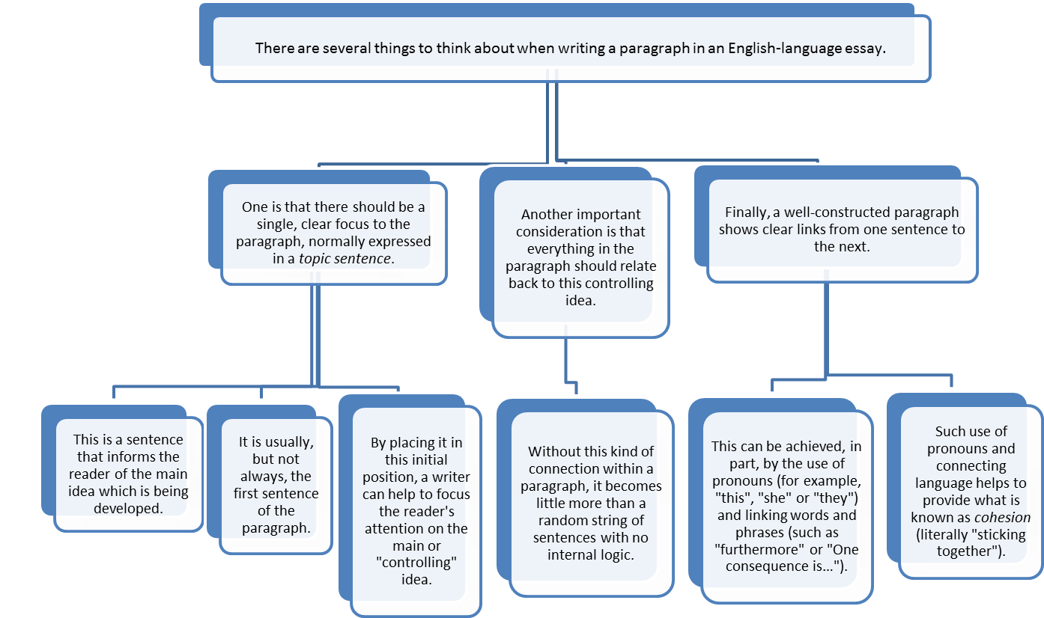

**“Level Two”  
elaboration**

**“Level One”  
elaboration**

**Main idea**

**(topic sentence)**

**Task 5: Brainstorming**

How many types of elaboration can you think of?

|  |
| --- |
| **Types of elaboration** |
|  |

There are many ways to elaborate ideas in a paragraph. Look at the example below.

|  |  |  |  |
| --- | --- | --- | --- |
| **Topic sentence:** There are several things to think about when writing a paragraph in an English-language essay. | | | |
| **Elaborating sentences** | One is that there should be a single, clear focus to the paragraph, normally expressed in a *topic sentence*. | **Classification**: the first of “several things to think about” | **Types of elaboration** |
| This is a sentence that informs the reader of the main idea which is being developed. | **Definition** of “topic sentence” |
| It is usually, but not always, the first sentence of the paragraph. | **Description** of where topic sentences are usually located |
| By placing it in this initial position, a writer can help to focus the reader's attention on the main or "controlling" idea. | **Explanation: effect -** explains the result of placing a topic sentence first in a paragraph |
| Another important consideration is that everything in the paragraph should relate back to this controlling idea. | **Classification**: the second “thing to think about” |
| Without this kind of connection within a paragraph, it becomes little more than a random string of sentences with no internal logic. | **Explanation: effect -** explains what happens if a paragraph is poorly constructed |
| Finally, a well-constructed paragraph shows clear links from one sentence to the next. | **Classification**: the third “thing to think about” |
| This can be achieved, in part, by the use of pronouns (for example, "this", "she" or "they") and linking words and phrases (such as "furthermore" or "One consequence is…"). | **Examples** of ways to “show clear links” from preceding sentence” |
| Such use of pronouns and connecting language helps to provide what is known as *cohesion* (literally "sticking together"). | **D*e*finition** of the word “cohesion” |
| **Concluding sentence:**  With practice, it becomes progressively easier to construct paragraphs which adhere to these three principles. | | | |

**Task 7: Identifying Elaboration Types**

Match the sentences below to the type of elaboration. One has been done for you as an example. You may need to use some types of elaboration more than once.

|  |  |  |  |
| --- | --- | --- | --- |
| **Topic sentence:** Theuse of online learning can increase student motivation significantly. | | | |
| **Elaborating Sentences** | 1. The term “motivation”, in this case, refers to an enthusiastic approach towards studying. | **E. Definition** | **Types of elaboration** |
| 2. According to Phillips (2011), one reason online learning promotes enthusiasm is that it allows students to work at their own pace. |  |
| 3. This can lead to more frequent study and higher exam scores. |  |
| 4. For example, Schmitt (2011) reports that University of Virginia students who worked online had, on average, a 12% increase in their final grades. |  |
| 5. It should be noted, however, that other research shows less evidence of major improvement (Choi, 2012). |  |
| 6. This difference in findings is not surprising, given the number of variables involved. |  |
| 7. Yet despite these disparities in the evidence, there is general agreement that online learning is a motivating factor in modern education. |  |
| 8. This is not merely a matter of GPA scores. |  |
| 9. As Daniels (2010) observes, many students report that as well as an increase in grades, they find online study to be less stressful than classroom tutorials. |  |
| 10. In other words, online learning can reduce the anxiety which sometimes accompanies face-to-face interaction. |  |

|  |  |  |
| --- | --- | --- |
| **A. Addition** | **D. Contrast** | **G. Explanation: cause** |
| **B. Comment/opinion** | **E. Definition** | **H. Explanation: effect** |
| **C. Concession (“Yes, but..”)** | **F. Evidence/data** | **I. Re-statement** |



|  |
| --- |
| **Some Thoughts on Elaboration**   * Remember, when planning and writing your paragraphs, to keep asking yourself: “What am I adding to the message by writing this sentence?” * Ask yourself: “Have I already made this point? If so, do I have good reasons for repeating it?” * Make sure that you always introduce an idea in your own words before bringing in a source, *e.g.* “This hasmany consequences. Pollard (2010) points out, for example, that…” * In addition, follow an idea from a source with some kind of elaboration on what the source has said. * Remember that there are many different types of elaboration. (See Task 5). Students tend to under-use **concession**, **comment** and **re-statement**. |

**Task 8: Revising your elaboration**

Choose one paragraph from the draft of your writing assignment. Exchange this paragraph with a partner. Check the paragraph for support and elaboration:

* Is there enough support?
* Is the support clear?
* Does the support add to the argument, or merely repeat what has previously been said?
* Does the writer comment on any sources with evidence of critical thinking?
* Are there any places where the reader might think “well, so what?”

Based on your answers to these questions, give your partner suggestions about how to revise the paragraph.

**Information Flow**

In English, information that is already known to the reader (“given” information, or the “theme”), general comes before new information. “Given information” may be an idea that has been mentioned previously in the paragraph, or it may be “common knowledge” and need no introduction. For example, consider the following two sentences:

1. Our experience of the material world is immediate, rich, detailed, and complex.
2. This complexity is partly due to the information received through our different senses.

In sentence A, the “given” information (assumed to be common knowledge) is *our experience of the material world*, while the new information tells us something about our experience (*immediate, rich, detailed, and complex*). In sentence B, the “given” information is *this complexity* (the new information in sentence A becomes the given information in sentence B), while the new information is *information received through our different senses*.

This “given 🡪 new” structure helps to provide links between information, establishes a “smooth flow” of ideas, and allows the reader to understand the information more easily. If a paragraph lacks flow, readers may become confused, feel that topics are out of order, or think that something is missing.

Information flow with in a paragraph can follow two basic patterns of development:

1. **Constant theme pattern**: This is where the given information occurs at the beginning of each sentence. This pattern is often used to focus on a particular topic, such as in scientific texts which describe a phenomena:

|  |
| --- |
| **The giant panda** is a bear native to south central China. **It** is easily recognized by the large, distinctive black patches around its eyes, over the ears, and across its round body. **In the wild, a panda** generally eats shoots and leaves, although it may occasionally eat birds or rodents. **The giant panda** has been driven out of the lowland areas where it once lived due to farming and deforestation. |

The information flow of this paragraph can be represented graphically as follows, where A is given information and B is new information:

|  |  |  |
| --- | --- | --- |
|  | **Given** | **New** |
| A 🡪 B | The giant panda 🡪 | native to China |
| A 🡪 C | It 🡪 | large black patches |
| A 🡪 D | In the wild, a panda 🡪 | eats shoots and leaves |

1. **Progressive Pattern**: This is where the new information of a sentence becomes the given information of the next sentence. It is often used to show a development from one idea to the next, such as in developing an argument:

|  |
| --- |
| **This type of product-based orientation**, however, can create serious problems. **One drawback** is that the formal patterns provided by the English teacher may not be realistic examples of texts that students encounter, or need to produce, during their academic studies (Hyland, 2003). For example, outside of the English classroom, **students** may never be required to produce a “cause and effect” essay for their university content teachers. |

|  |  |  |
| --- | --- | --- |
|  | **Given** | **New** |
| A 🡪 B | Product-based orientation 🡪 | Serious problems |
| B 🡪 C | One drawback 🡪 | Not realistic examples that students encounter |
| C 🡪 D | Students 🡪 | May never produce a “cause and effect” essay |

However, more typically, a paragraph would follow a combination of these two patterns, as represented below:

|  |  |  |  |
| --- | --- | --- | --- |
| Sentence 1 | A (given) 🡪 | B (new) |  |
| Sentence 2 |  | B (given)🡪 | C (new) |
| Sentence 3 |  | B (given)🡪 | D (new) |
| Sentence 4 | A (given)🡪 | E (new) |  |
| Sentence 5 |  | E (given)🡪 | F (new) |
| Sentence 6 |  | E (given)🡪 | G (new) |

**Task 9**

Analyse the following student paragraph in terms of its information flow. In each sentence, draw a circle around the given information and a square around the new information. Then draw arrows to show how the given information relates to previous sentences. (You can use coloured pens, if you have them).

|  |
| --- |
| Nuclear energy is not a safe, clean and reliable energy. Nuclear power is generated by nuclear fission. It will not produce carbon dioxide or air pollution, but during the nuclear fission process, radiation is released. The radiation is usually so small that may not cause any effect, but if any accidents happen, large amounts of radiation could be released in the surrounding area, destroying the environment and causing large scale loss of life. Nuclear disaster would bring ecological disaster and many kinds of animals and plants would disappear. The delicate balance of the eco-system would be compromised. After the Chernobyl disaster, for example, the radiation leak caused large scale destruction and loss of life. |

**Task 10**

The following paragraph was written by a student and arguing that social indifference is not a problem in Hong Kong. The paragraph is an example which does **NOT** follow the principles of information flow. Discuss with a partner where the paragraph lacks flow and suggest how the paragraph could be rewritten to achieve better flow.

|  |
| --- |
| Citizens are very concerned about the issues related to them. If the case is beneficial and pressing to them, they will get involved. There is a serious housing shortage in Hong Kong. Citizens think that it is important for the Chief Executive to solve this difficulty. According to a survey done by the University of Hong Kong (HKU Pop Site, 2016), above 90% of the interviewees believe that is essential for the housing problem to be included in the policy address. We realize that living is one of the basic necessities. People who live in this city are going to reveal their needs by protesting and demonstrating when the government does not take any action. It presents that residents will fight against injustice. This case also verifies social indifference rarely emerges in society. Everyone will strive for better rights and interests while both of them eventually benefit those parties. |

**Task 11**

Choose one paragraph from the draft of your writing assignment. Exchange this paragraph with a partner. Check the paragraph for information flow and give your partner suggestions about how to achieve better flow within the paragraph.

|  |
| --- |
| Internet1[1]**Useful Resources**  <http://learningcentre.usyd.edu.au/clearer_writing/module1/paragraph_structure/body/body_intro.html> - This interactive web site shows examples of many types of elaboration  <http://learningcentre.usyd.edu.au/clearer_writing/module2/info_structure_intro.html>- This interactive web site a detailed explanation, with examples, of information flow.  <https://www.youtube.com/watch?v=W5V9n_FoSzU> - This website from the University of North Carolina presents a short video clip (about 2 minutes) about information flow. |